Exercise Part 1

Facebook Example

* **Union Bank of the Philippines** is a leading commercial bank known for its comprehensive financial services, including robust retail and corporate banking solutions. The bank offers a diverse range of credit card products that cater to various customer needs, providing rewards, cash back, and competitive interest rates.



1.) For this example, they utilized a Facebook ad to invite potential applicants to enjoy no annual fee for life when they spend at least 20,000 pesos within 60 days of card approval. This enticing offer aims to provide long-term value for cardholders and encourages responsible spending. By promoting this benefit, Union Bank seeks to attract new customers and enhance their credit card services.

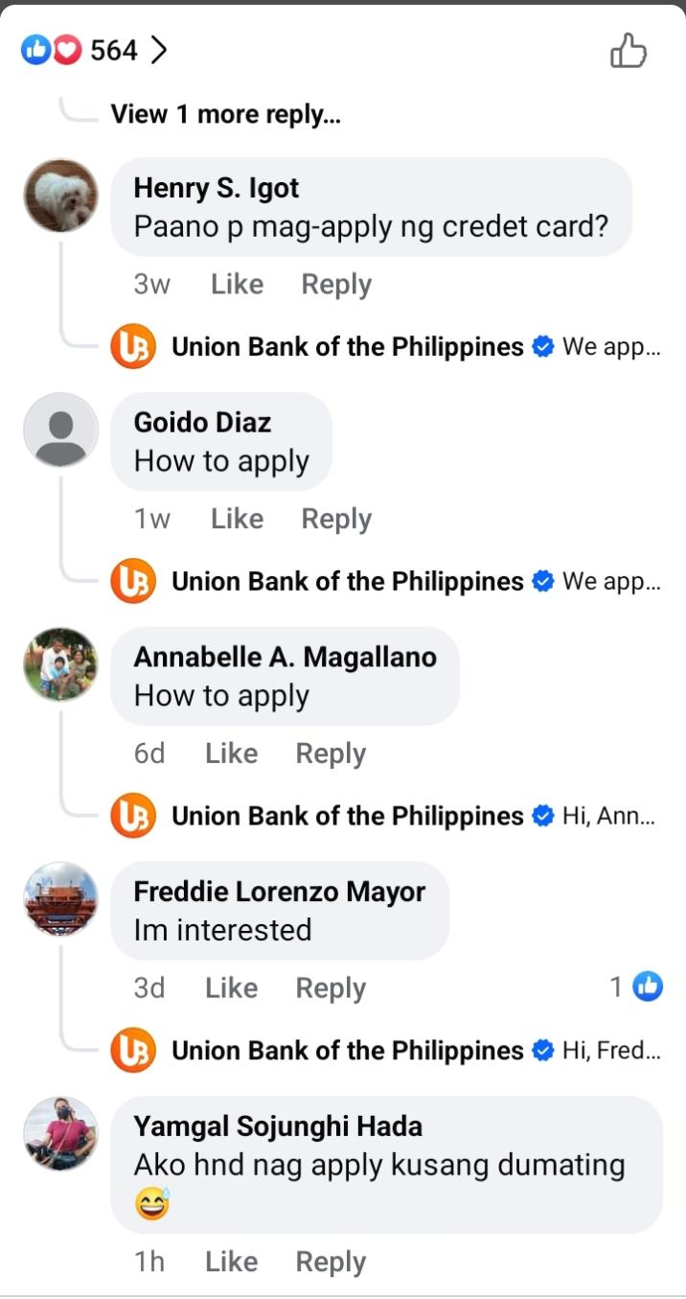

2.) As for the users, they can like, share, or comment on the ad to engage and mention someone who may be interested in applying. They also have the opportunity to inquire about the advantages and disadvantaged of the credit card. Users can also directly apply for approval, making the application process more accessible.

* **Dairy Queen** is a fast-food restaurant chain known for its soft-serve ice cream and treats. It was founded in 1940 and has locations in many countries.

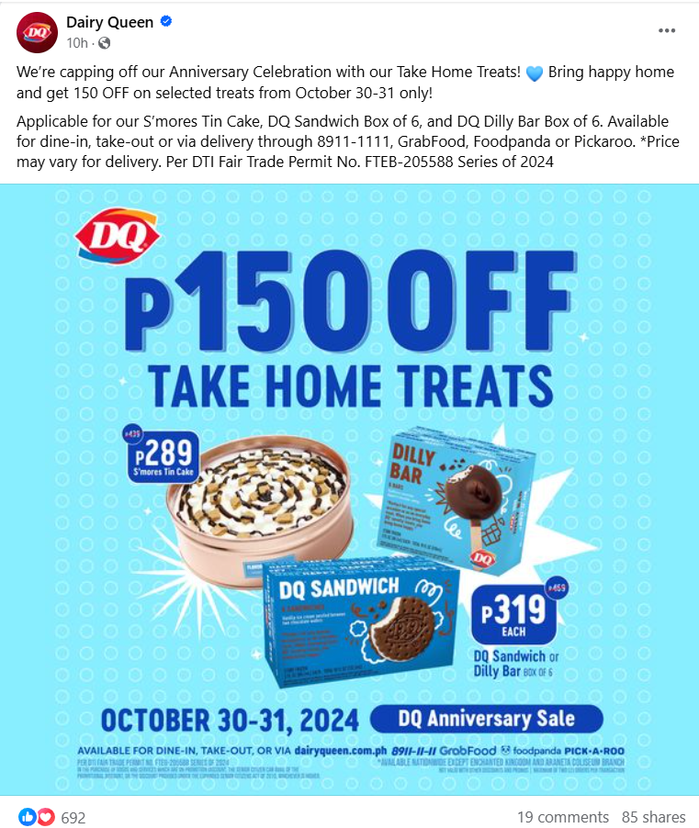

1.) For this example, they used a Facebook ad to promote a 150 pesos discount on selected take-home treats for their anniversary celebration. This offer aims to attract customers and encourage them to celebrate with special treats. The promotion highlights their anniversary and makes the products more affordable.

2.) For dessert lovers, this ad is effective because it offers a discount. The promotion makes the treats more appealing. Discounts like this can attract many customers who enjoy sweets.

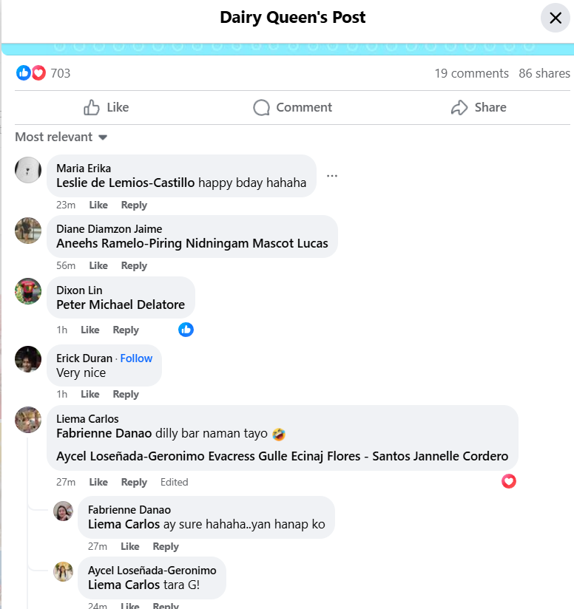

# Tasks

### **How does the brand try to engage users?**

1. The brand engages users by offering no annual fee for life if they spend at least 20,000 PHP within 60 days of card approval. This incentive encourages customers to use the card more. By removing the fee, the brand makes the offer more attractive to potential users.
2. The brand in example 2 engages users by offering discounts to attract customers. This strategy encourages people to purchase their products. By providing deals, the brand makes itself more appealing and increases customer interest.
3. The brands engage users by sharing interesting content about their products and services. They also respond to customer questions in comments and direct messages. This interaction helps build a stronger connection with their audience.

### **What type of content is the consumer engaging with or sharing?**

* Consumers engage with content that they can relate to, often commenting or asking questions about the products and services.
* General consumers are drawn to interesting content, such as enticing offers, inspirational messages, or funny posts that create excitement.

### **What goals might the marketer and consumer have?**

* For the marketers, the goal is to attract more users and increase the number of customers utilizing their products and services, while also boosting engagement and building relationships with their audience.
* For the consumers, the goals include obtaining favorable discounts, winning giveaways, and simply liking or enjoying the content.

# Part 2: Reflection

### **Do you see yourself behaving more like a marketer (strategic posting) or a consumer (interacting with posts)?**

### I see myself as more of a consumer, enjoying the interaction with posts and engaging with content that catches my eye. While I appreciate the creativity behind strategic marketing, I love sharing my thoughts and connecting with others through comments and likes. However, I can’t help but wonder how people come up with such great ideas when I see a particularly impressive post.

### **What platforms do you use most often, and for what purpose?**

### I mostly use Facebook and TikTok for browsing. These platforms allow me to explore interesting content and stay connected with friends. I enjoy scrolling through various posts and videos that catch my eye.

### **How do brands influence your decisions when you interact with them on social media?**

* Brands influence my decisions on social media by sharing engaging and relatable content that captures my attention. Their responsiveness to comments and questions creates a sense of connection, making me feel valued as a customer. This positive interaction often encourages me to explore their products or services further.